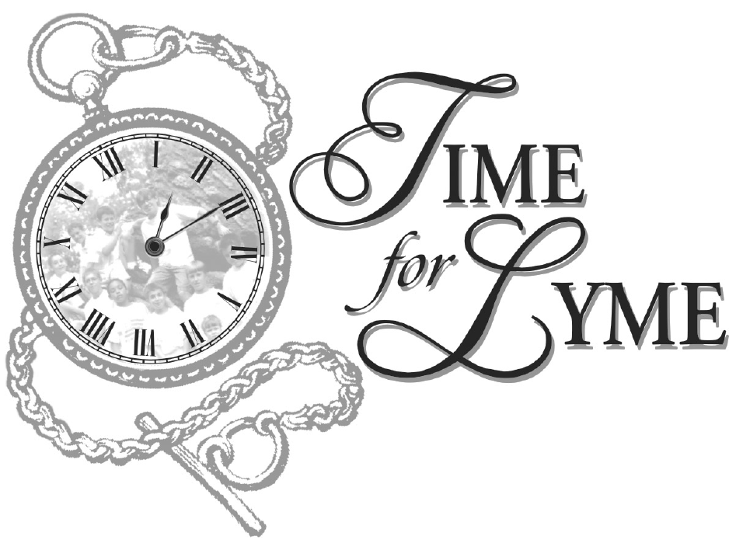 Lyme Disease: The Diagnostic Dilemma

We are all at risk for Lyme disease!
What should you know to protect your family?

This video is an effective tool to help recognize Lyme and other tick-borne diseases that are prevalent in your community. Learn from a nationally recognized group of experts about the difficulty in diagnosing Lyme disease. Introductory remarks by Amy Tan author of the Joy Luck Club and CT Attorney General Richard Blumenthal.

Guest Speaker: Richard Horowitz M.D. Board Certified, Internal Medicine
Former Assistant Director of Medicine, Vassar Brothers Hospital,
First Vice President – International Lyme and Associated Disease Society
Dr. Horowitz is a practicing physician in Hyde Park, New York who specializes in the diagnosis and treatment of Lyme and other tick-borne diseases.

Discussion Panel

Caroline Baisley, Director, Greenwich Department of Health
Brian Fallon, MD (Neuropsychiatry), Director, Columbia Lyme Disease Research Center,
Columbia University Medical Center
Amiram Katz M.D. Board Certified, Neurology, Norwalk Hospital
Johnny Lee, MD, Director, Stamford Department of Health
Pat Smith, President, Lyme Disease Association, Inc.

For more information, please call: Time for Lyme, Inc. (203) 969-1333
Cost per video: $15 VHS/ $20 DVD – Please allow three weeks for delivery.
____________________________________________________________________________
Please send _______ DVD(s) at $20 each Total Cost __________
Please send _______ VHS(s) at $15 each Total Cost___________

Please Print Delivery Address:

Name: __________________________________________________________________________________

Address: ________________________________________________________________________________

E-mail Address: __________________________________________________________________________

Phone Number: ________________________ May we add you to our mailing list? Yes___ No ____

Payment Method:

My check for $________ is enclosed (make checks payable to the Time For Lyme, Inc.)

Please charge my account $_________We accept Visa, Master Card, and American Express.

Card #____________________________________________Exp. Date_________________

__________________________________________________________________________
Authorized Signature
Thank you for your order!

Time For Lyme, Inc. (Affiliate of the Lyme Disease Association, Inc.)
P.O. Box 31269
Greenwich, CT 06831
(203) 969-1333

