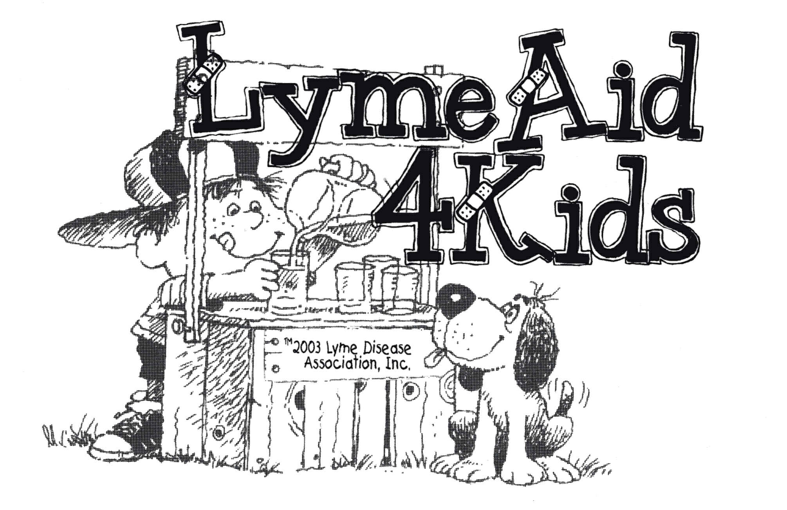

NOTIFICATION
JULY 2008

Due to a high volume of funds granted in 2008 to date, LymeAid4Kids funds for 2008 are depleted, and further monies are unavailable at this time.

Please check back later for updates on availability of funds for 2009.

