PO Box 1438, Jackson, New Jersey 08527
    - Lymeliter@aol.com
LymeDiseaseAssociation.org

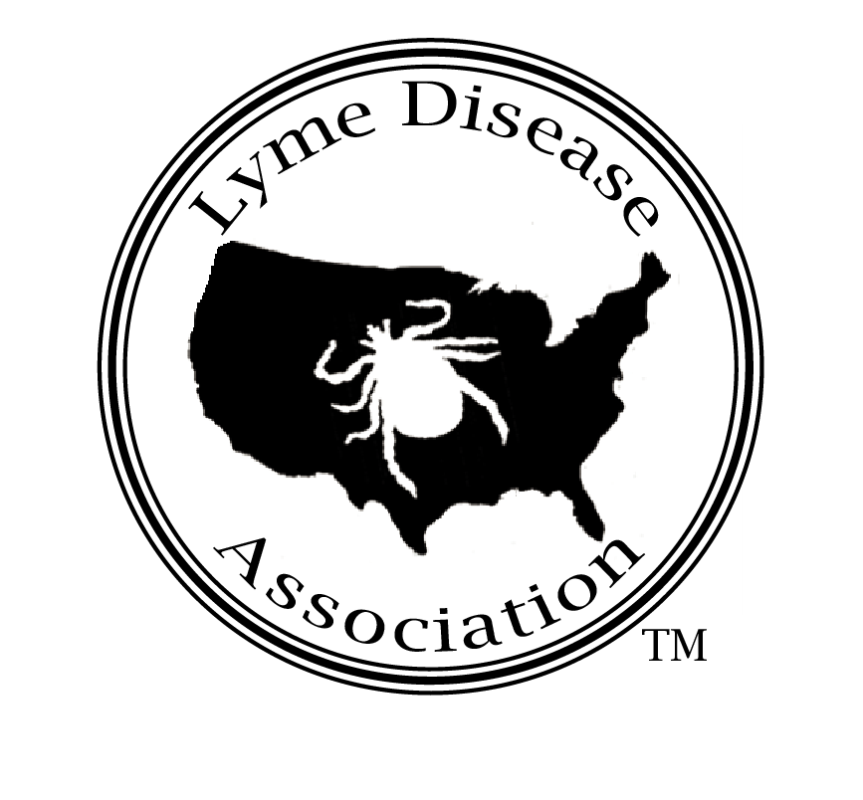
Lyme Disease Association, Inc.

Washinton, DC, meeting with Military at Office of Congressman Christopher Smith
By Pat Smith, President, Lyme Disease Association, Inc. 9-18-02

I am President of the Lyme Disease Association, LDA, an all-volunteer national organization providing Lyme disease education and funding for research projects coast to coast, including a grant to the USDA on biological tick control using nematodes. The LDA has acquired five national affiliates and with its Greenwich (CT) affiliate, has partnered with Columbia University College of Physician & Surgeons in the opening of an endowed chronic Lyme disease research center to be housed at Columbia. We are beginning a national fundraising effort for the center, having already contributed $.7 million with $2.3 million left to open the center. The Association also provides free educational presentations including one at McGuire AFB to the 621st AMOG a few years ago.

I also sit on the board of directors of International Lyme and Associated Diseases Society, ILADS, a professional medical organization, and am former chair of (NJ) Governor’s Lyme Disease Advisory Council.

When the LDA first began to hear of Lyme and other tick-borne disease (TBD’s) complaints from members of the military, many of us wondered how could that be? After all, it has not been that long since LDA visited US Army Centers for Health Promotion and Preventive Medicine (CHPPM). We were surprised and pleased at its aggressive tick-borne disease prevention activities including
- impregnating uniforms at the time of manufacture with permethrin for troops going into tick infested areas,
- the DoD human tick test kit program,
- study of co infections such as babesiosis and Ehrlichiosis, and
- development of a pocket-sized lab to test ticks in the field so that soldiers may receive immediate treatment if bitten by ticks that test Lyme positive by PCR.
- Tick risk assessments have long been performed at most major military installations, and CHPPM told us that data showing tick populations will/has been accessed by GPS satellites. A prototype helmet with a “heads up” display is being developed which will be worn by soldiers in the field, and the tick data will be beamed to the “heads up” display showing the soldiers where the heaviest tick concentrations are, allowing troops to maneuver around them.

The LDA even touted the work of CHPPM by inviting one of its researchers to present at our medically accredited conference, co-sponsored with Columbia University last year. LDA also featuring a speaker from NASA, describing the joint NASA/ NIH 3-dimensional culturing project for Borrelia burgdorferi using microgravity chambers, which mimic conditions in space and in the human body. Our website, LymeDiseaseAssociation.org, has video segments of both the 3-D culturing as well as CHPPM’s conference presentation.

As the volume of complaints from military families increased, we decided to seek the help of Congressman Smith to not only discuss these complaints but also to provide information we hope will be helpful to the military in coping with the dangers of tick-borne diseases.

Lyme is the most commonly reported vector-borne and tick-borne disease in the U.S. and the most prevalent tick-borne disease in the world. Reported cases in the US must meet the CDC (Centers for Disease Control & Prevention) surveillance criteria: a physician diagnosed EM (bullseye) rash, or positive blood work and other system involvement. Nationally reported case numbers rose 8% in 2000 to 17,730 cases, a figure the CDC itself estimates may represent only 10 to 20 percent of those cases actually meeting its surveillance criteria. Using the conservative 10% only being reported, that equals 177,300 probable new cases for the year 2000.

Besides those not fitting the above criteria, increasing case numbers in the south including Florida, North Carolina and Georgia are often not reported as Lyme, since some of the disease being transmitted there is transmitted by the Lone star tick, Amblyomma americanum. It has been dubbed STARI (southern tick-associated rash illness) or Lyme-like illness, and the CDC has been reluctant to characterize it as Lyme because its bacterial agent, Borrelia lonestari, remains uncultured.

The CDC states on its website “This surveillance case definition was developed for national reporting of Lyme disease; it is not appropriate for clinical diagnosis.” One of the problems inherent in the criteria is the fact that studies have shown that the EM rash appears less than 50% of the time, and that other types of rashes may appear, or they may be no rash at all. Another problems lies in the inaccuracies of Lyme disease testing⎯antibody response test results are often unreliable for Lyme, sometimes producing negative results when the victim has the disease. This may in part be due to the fact that antibodies and antigen have been shown to complex, and the ELISA, e.g., can only test for free antibody. According to a document from the NY Department of Health to the CDC, if they followed the 2-tier testing requirement for 1995 cases (positive ELISA followed by Western Blot), 81% of non-EM cases would not have been confirmed. Despite CDC warnings, many physicians do use the surveillance guidelines to diagnose, instead of making a clinical diagnosis based on symptoms and history as the CDC recommends.

New Issues Concerning Tick-borne Diseases: Blood Supply
An issue with TBD’s that has come to the forefront is how they affect the blood supply. New Red Cross blood donor guidelines state “Accept persons with Lyme disease if they were treated, the disease resolved and at least one year has passed. Those with chronic Lyme disease are not eligible to donate blood.” Individuals who had babesiosis are also prohibited from giving blood. The American Society of Clinical Pathologists (ASCP) released blood donor guidelines a year ago⎯under “serious illness,” defer indefinitely babesiosis and Lyme disease. In their April 1999 report to Congress entitled Activities Regarding Lyme Disease and Other Tick-borne Diseases, CHPPM expressed its concern about the blood supply and tick-borne illness, mentioning Ehrlichiosis and possibly Rocky Mountain Spotted fever as having been transferred through blood transfusions. Several studies in peer review discuss the actual transmission of babesiosis through the blood supply.

V.I. Technologies, Inc. (Vitex), a biotechnology company, announced the successful test of a product that inactivates both Borrelia burgdorferi and the West Nile from the transfusion blood supply. Vitex President and CEO John Barr, while announcing an agreement with the FDA to initiate a Phase III clinical trial program with the pathogen reduction red blood cell system, stated “Both pathogens share an asymptomatic period in which blood donor guidelines would not exclude blood donations by persons during this stage. West Nile virus and the bacterium that causes Lyme disease are prime examples of emerging pathogens. Further epidemiologic studies in human transfusion recipients are needed before the transfusion risk, if any, can be ascertained.”

The blood donation guidelines for TBD’s have been in place, but the shift has come with the ineligibility of those with chronic Lyme disease to donate, the segment of the Lyme disease patient population often underserved by physicians. To quote the CDC, “In later disease, treatment failures may occur and retreatment may be necessary.”

The issue of treatment failure and chronicity of infection is the heart of the problem within both the civilian and military patient population. The treatment controversy pits academic-based physicians who feel Lyme is cured with 28 days of treatment against physicians in the trenches who are treating Lyme cases and their patients who are experiencing symptom relief from extended treatment. Experience on both sides has shown if Lyme is diagnosed and treated early, it can be treated rather successfully with appropriate dosages of antibiotics. However, a lack of a definitive test, its ability to mimic other diseases, and the presence of co infections often complicates diagnosis and treatment and may lead to chronic disease.

Research reported by Dr. Allen Steere has also shown that the Lyme disease spirochete can enter the central nervous system of an animal in 12 hours after inoculation with the spirochete, and a nonhuman primate study reported in Neurology by Andrew Pachner states “These data support the hypothesis that the pathogenesis of LNB is associated with direct spirochetal invasion, and provide evidence that CNS involvement is more common than heretofore thought.” The authors also conclude that the study demonstrates the NHP model is a reliable model faithful to human disease. From a JAMA study (Dattwyler, Stony Brook) “Our findings demonstrate that Bb can disseminate to CNS very early in the infection with little or no clinical evidence of CNS involvement….the CNS may act as a sanctuary for Bb, protecting it from the action of systemic antibiotics and immunity and thereby allowing it to reseed the periphery intermittently.”

CNS Lyme disease can be very difficult to eradicate, as you will hear from Dr. Fallon. Additionally, some recent work including that of Dr. Martin Fried, pediatric gastroenterologist, demonstrates that the spirochete seems to survive in the GI tract even after treatment for Lyme disease. He studied ten previously treated patients, biopsied their GI tract then used stain of biopsies and PCR, to show all remained positive for Borrelia. None of the controls were PCR positive for Borrelia.

There are many examples in peer review to explain how the spirochete can persist in the body after treatment. Dr Liegner will discuss the possible mechanisms of persistence of Borrelia burgdorferi in detail but I just want to briefly mention the following works. Research performed by Dr. David Dorward, NIH, Rocky Mountain Labs, has shown that the spirochete that causes Lyme disease can enter a cell and come out the other side cloaked in the cell’s membrane, thus eluding the body’s immune system, which no longer recognizes the spirochete as a foreign invader. The spirochete has also been shown to persist within macrophages by Montgomery et al. and in Nanagara, Duray and Schumacher, spirochetal antigens have been found to persist in the joint in chronic Lyme disease, both intracellularly and extracellularly in deep connective tissue, suggesting the ability to elude host response and antibiotic treatment.

Also, research by Brorson & Brorson shows that the spirochete, in vitro, is able to change itself into different forms. The change in form may occur in vivo under conditions unfavorable to the spirochete. The work of Alban et al indicates that the spirochete reacts to conditions of serum starvation by changing cell morphology. This can explain how the spirochete is able to survive periods of nutrient deprivation in host tissues. Some of these new forms may lack a cell wall, thus eluding cell-wall targeting antibiotics. When the climate gets better, the cell wall-less forms may change back into the spirochete, and the disease may become active again.

Dr. Reinhard Straubinger, a world renown Lyme researcher with famous dog studies at Cornell, recently wrote to the NY State Department of Health that he was able to culture spirochetes from 3/23 30-day antibiotically-treated dogs (human dosage comparable), detect spirochetal DNA in 20, and quantify spirochetal DNA in 12. He used his work to explain why long term antibiotic studies may not have demonstrated persistence “In contrast to many human studies we could show persistent infection, because a lengthy time period separated the phase of treatment and the phase of testing.…the spirochetes may need sufficient time after antibiotic treatment in order to recover and multiply to sufficient numbers so we can detect them with the techniques we have currently available.”

Clearly, the answers are not all in, and the lack of knowledge by treating physicians is reflected in the human suffering taking place. Among civilians, that may affect the patient and his/her family only, in the military, it may put us all at risk.

CHPPM Human Tick Test Kit brochure
Lyme & Other Tick-borne Diseases: A Twenty-first Century View, LDA conference pamphlet
USACHPPM website
“The bdr Gene Families of the Lyme Disease and Relapsing Fever Spirochetes,” Roberts, David M., et.al., Emerging infectious Diseases, 6(2), 2000. Centers for Disease Control
HMS Beagle, Issue 106, 7/6/02 The Bitter Feud over LYMErix Big Pharma Takes on the Wrong Little Osp, P. Weintraub
CDC website
CDC Website Lyme/casedef2.htm
Eur Neurology,1995:35(2):113-7 C. “Seronegative Chronic relapsing Neuroborreliosis,” Lawrence et al. Albert Einstein College of Medicine
JAMA, 11/24/99, Vol. 282, No.20, “Borrelia Burgdorferi--Specific Immune Complexes in Acute Lyme Disease,” Steven Schutzer, UMDNJ
NYSDOH to CDC April 15, 1996
American Red Cross website www.redcross.org
Press release American Society of Clinical Pathologists
USA CHPPM 4/1/99 Activities Regarding Lyme Disease and Other tick-borne Diseases, p. 6
Transfusion Associated Transmission of Babesiosis in New York State, Linden, et al, Transfusion 2000, Mar A Cluster of Transfusion Associated Babesiosis cases traced to a single asymptomatic donor, JAMA, 3/10/99
Mandell, Douglas and Bennett’s Principals and Practices of Infectious Disease, 4th ed, Allen Steere, p. 2145
JAMA ,3/11/92, Vol 267, No.10 Luft, Dattwyler, et. al.
Journal of Spirochetal & Tick-borne Diseases, Spring/Summer 2002, Vol.9, Martin Fried, MD
Lyme & Other Tick-borne Diseases: Focus on Children & Adolescents, LDA conference brochure photo
Journal of Immunology 1993 Feb1;150(3):909-15
Human Pathology, 1996 Oct;27(10)1025-34
Infection 1997Jul-Aug;25(4):240-6
Microbiology 2000Jan;146 (Pt 1):119-27
Dr. Straubinger’s letter to NYSDOH, November 22, 2001

