PO Box 1438, Jackson, New Jersey 08527
    - Lymeliter@aol.com
    - www.LymeDiseaseAssociation.org

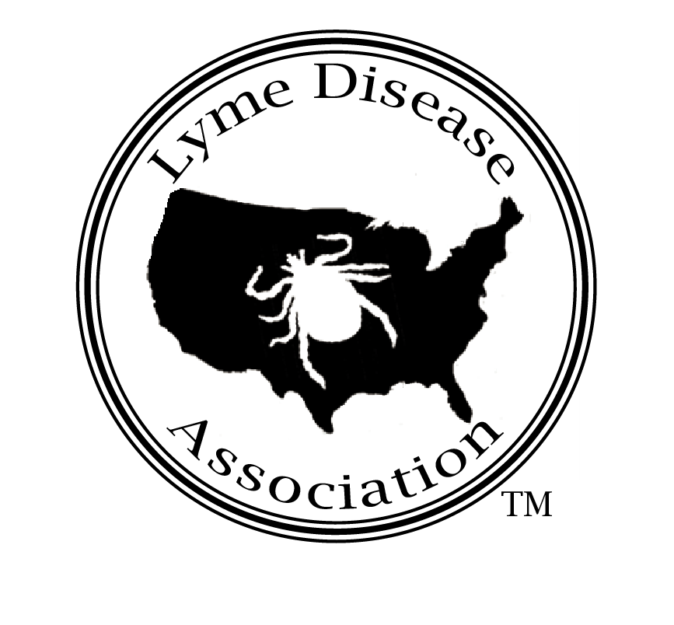
Lyme Disease Association, Inc.

Testimony to New Jersey Assembly Health Committee June 12, 2006
By Pat Smith, President, Lyme Disease Association, Inc.

According to the CDC (Centers for Disease Control & Prevention), Lyme is the most prevalent vector-borne disease. Research shows the Lyme bacterium has the ability to enter the central nervous system less than a day’s time after a tick bite, yet the federal government’s expenditures on Lyme disease total ~$32M annually for 22-24,000 reported cases, compared to WNV expenditure of ~ 77M for ~ 2,500 reported cases.

Lack of funding, focus and communication about Lyme have led to inadequate public and physician education, misconceptions about Lyme’s seriousness, and lack of treating physicians. A climate of fear exists nationwide for treating physicians who are often afraid to diagnose and treat patients due to medical board investigations of those treating chronic Lyme. These investigations are often initiated by insurers or other physicians who do not recognize chronic disease or understand there are two standards of care for Lyme. Sanctions including supervision, fines, losing ability to treat Lyme patients, and license suspension and revocation have created a situation where patients are unable to obtain diagnosis, treatment, insurance reimbursement, disability, education or even understanding from their families and peers.

CDC reported case numbers nationwide for Lyme have ranged from 20,000-24,000, representing only 10% of actual cases meeting the CDC surveillance criteria ─so up to 240.000 new cases occur annually that do meet the CDC criteria, a number that does not even include cases that fall outside the CDC surveillance criteria. Preliminary 2005 CDC numbers show Pennsylvania (5449) New York (4031), and New Jersey (3372), 1,2,3, respectively, in reported Lyme cases, with a 25% increase in NJ cases over 2004 (2698).

Cases meet the CDC surveillance criteria if the patient has a physician-diagnosed EM (bull’s eye) rash, or positive blood work and major system involvement (cardiac, neurologic, musculo-skeletal). Studies show EM appears less than 50% of the time. Lyme disease testing, especially the initial required screening test, the ELISA, is highly inaccurate. According to a letter from the NY DOH to the CDC, if NY had followed the 2-tier testing requirement for a particular year─ a + ELISA then followed by Western Blot─ 81% of non-EM cases would not have been confirmed. A Johns Hopkins study evaluating Lyme disease testing said current tests are about 75% inaccurate. Studies published in JAMA and elsewhere show that Bb antibodies form immune complexes, limiting the ability of the ELISA screening test, since it can only detect free antibody.

CDC states doctors should not use surveillance criteria for diagnosing Lyme, yet many physicians do. Two camps have been created─one,the institution-based physicians who see few Lyme cases, diagnose based on CDC surveillance criteria, and treat short-term using IDSA guidelines; the other, primarily private practice physicians who diagnose clinically and treat long-term when necessary following the ILADS (International Lyme & Associated Diseases Society) guidelines, and their patients, who are experiencing symptom relief from extended treatment.

The dispute arises partly because of improper use of CDC criteria to diagnose, unreliable testing, Lyme’s ability to mimic other conditions such as CFS, FM, MS, ALS, Lupus, even autism and Alzheimer’s, and its likelihood to be accompanied by other tick-borne diseases, clouding the diagnostic and treatment picture further. Babesiosis, bartonelliosis, anaplasmosis (aka human granulocytic ehrlichiosis), are being seen concurrently in patients in the Northeast. Delaying treatment or providing inappropriate treatment can lead to chronic Lyme disease, developed by an estimated 15% to 34% or more of patients.

Patients diagnosed with chronic Lyme often cannot buy life insurance, nor can they donate blood. Red Cross blood donor guidelines say, “Accept persons with Lyme disease if they were treated, the disease resolved and at least one year has passed. Those with chronic Lyme disease are not eligible to donate blood.” The American Society of Clinical Pathologists’ blood donor guidelines state “defer indefinitely…Lyme disease.” The bacterium that causes Lyme has been shown to survive blood banking conditions, although to date, no cases of Lyme disease transmission have been reported through blood donations, although babesiosis has been reported through transfusion.

Doctors’ dilemma: do they treat sick patients who do not meet the CDC surveillance criteria and patients with chronic symptoms? Besides pressure from medical boards, doctors are pressured by insurance companies that often deny coverage to anyone not meeting CDC surveillance criteria, despite CDC warning that the criteria are not meant to be used for reimbursement. Insurance carriers strongly suggest to doctors they stop treating Lyme patients long-term or leave the plan. An insurance company letter to a New Jersey patient typifies the status quo: “Unfortunately, a number of unscrupulous practitioners in this and neighboring states have held themselves out as experts in the treatment of Lyme disease…. Because our organization has been appropriately vigilant and aggressive in dealing with certain practitioners, they have chosen to leave our network.”

The scarcity of treating physicians coupled with increased demand for them, has created a health care access crisis, with many patients traveling great distances to receive treatment from Lyme specialists. Access to health care is essential for patients with chronic Lyme disease. As a recently funded National Institutes of Health (NIH) study points out, these patients suffer a degree of disability equal to that of patients with congestive heart failure. Many are unable to work or properly care for their family. Failure to address their need for health care swells the disability rolls of states and ultimately increases health care costs as untreated patients impose a heavier burden on emergency and medical support systems.

School systems are burdened as Lyme students are classified and home instruction roles increase with students unable to attend school due to chronic disease. A Columbia University study shows a Lyme student drop in IQ of 22 points, rectified with treatment. The cost to states in both disability and education dollars is measurable and significant. The cost in human suffering is staggering but un-measurable, but surely weighs heavily on the conscience of any reasonable person.

The legislature or executive branch in some sates has intervened to correct injustices to patients, e.g., NY’s memo from the (Office of Professional Medical Conduct) OPMC to its staff stating that physicians cannot be investigated based solely on their long-term treatment of Lyme disease; RI and CA’s doctor protection laws. PA has a doctor protection/mandatory insurance coverage bill passed the house and awaiting senate action. RI has mandatory insurance coverage, and FL, MD, and MN have (are) also considered Lyme disease legislation. In NJ, we have worked with the NJ State Board of Medical Examiners to place Lyme literate physicians on its Review Board, and A-269 (Chivukula) mandating coverage for testing and treatment of tick-borne diseases has been introduced.

As you know, companion bills have been introduced into the US House (HR-3427 Smith/Kelly) and US Senate (S-1479 Dodd/Santorum), providing $100M over 5 years for Lyme disease research and education. Both US Senators (NJ) have signed onboard and 50% of NJ congressmen. Almost 70 congressmen to date support the bills, which also create a patient/ physician/researcher task force with input to Health & Human Services (HHS). Thanks to the NJ Assembly for unanimously approving AR-55 supporting these bills.

LDA has briefed HHS in DC on doctor-patient issues and expects to meet shortly with HHS Secretary and the CDC Director for further discussion. In 2005, for the 2nd time, LDA met with US Army CHPPM (Centers for Health Promotion & Preventive Medicine) at Aberdeen Proving Grounds where they are testing ticks from US military bases for Lyme and other tick-borne diseases. The army has also developed a laptop-sized testing device which can be used in the field for PCR testing of ticks so that those bitten can immediately know if the tick carries Lyme disease and can receive treatment if necessary. It has patented the device and is in discussions with a private company to produce the product.

Since the late 80’s, CHPPM has mapped and created risk assessments for Lyme disease at US military installations and is now adding tick infectivity rates. The information can be beamed to satellites and then eventually to handheld receivers to be carried in the field, advising the troops where the population and infectivity rates of ticks are high, so they may maneuver troops around high risk areas. CHPPM has recently used the tick data on its Virginia Ft. A.P. Hill installation which hosts the Boy Scout jamboree to determine tick location so they could map and spray those areas for ticks before the Scouts arrived.

NASA and the NIH have a joint culturing project for bacteria including Borrelia burgdorferi, the Lyme disease causative agent, using microgravity chambers, which mimic conditions in space and in the human body. This could lead to better success culturing this organism which now is difficult to do. The NIH has just funded a study to map the genome of the deer tick, and according to one of the NIH project researchers, tick expert Dr. Stephen Wickel, the army just kicked in almost $5 million because they fear that ticks will be used to spread bio warfare agents.

Tick control should have been a priority. 20 years ago, central NJ was considered to be the northernmost range of the lone star tick, a tick much more aggressive than the deer tick. Instead of waiting quietly on low lying vegetation for a passing animal to brush against it, the lone star will stalk you from 30 feet away. It has spread up to Maine and a recent study placed it in Mass and NY. It is carrying Ehrlichiosis (HME), tularemia RMSF and STARI, southern tick-associated rash illness, a Lyme-like disease that causes the same symptoms and rash. Few in NJ or anywhere recognize the lone star’s presence or the fact it is spreading disease.

Preventive measures need to be combined with measures to solve the problems of those already infected with chronic disease and those at risk for developing it. Physicians’ right to freely practice medicine without vested-interest interference and the patients’ right to receive timely diagnosis and appropriate treatment need to be considered in the context of a quote from CDC spokesman Paul Meade in the NH Union Leader. "Can I say chronic infection never, ever occurs? No, of course I can't, and that's where one has to not be dogmatic about these things," says Meade.

Today’s hearing is necessary and not unprecedented. New York, Connecticut and RI held 2 full day dedicated Lyme disease hearings, the latter running until midnight, Texas and California, one dedicated hearing each. Pennsylvania House majority caucus invited LDA to present several times as have the governors of New Hampshire and RI.

The legislature should consider passing A-269 (Chivukula) mandating insurance coverage and consider introducing NJ doctor protection measures. Adoption of such measures will ensure that patients receive necessary diagnosis and treatment, cutting costs long-term by reducing disability, special education costs, and the other costs associated with chronic Lyme disease. You have the rare opportunity to save thousands of people untold suffering, many of whom may be our children and grandchildren, who run some of the highest risk of acquiring the disease. Playing outdoors, petting the dog, rolling in the leaves, and sitting on a log are all risky behaviors for the development of Lyme disease, yet are all activities enjoyed by children. Keep that in mind while listening to patient stories today. Thank you.

§

Other Recommendations, Footnotes, & Background Page

Other proposed solutions

For the Department of Health (DOH):
- send letters to all licensed physicians in the state: CDC surveillance criteria are not to be used for diagnosis; Lyme is a mandatory reportable disease.
- send letter to DYFS telling them not to charge parents with Munchausen’s by proxy for having children treated long-term for Lyme disease by licensed physicians.
- require Lyme disease continuing medical education (CME) credits for state-licensed physicians. Alert physicians about available conferences including those that cover chronic Lyme disease such as LDA/Columbia University conference and the ILADS conference to be held October 20 and the 21st/22nd, respectively, in Philadelphia.
- develop a system to track physician-diagnosed cases that do not meet CDC criteria to determine the true incidence of the disease. The DOH already has these reports from physicians.
Department of insurance (DOI): alert insurers that they cannot deny Lyme disease treatment based on the CDC surveillance criteria.
Department of Education (DOE): remind school districts that mandatory inservice is required for staff who have children with Lyme disease, keep properties maintained, post tick warnings where necessary, and develop trip policies reflecting high risk areas.

Steere, Allen, Mandell, Douglas, & Bennett, Principle sand Practices of Infectious Diseases, 4thed. 1995.
The Front Line Against Lyme Disease, Herald News May 4, 2004. NJ (Meade, Paul CDC )
P. Coulter et al, J. Clin Microbiol.. 2005Oct.; 43(10): 5080-4 Two Year Evaluation of Borrelia burgdorferi Culture and Supplemental Tests for Definitive Diagnosis of Lyme Disease
S. Schutzer et al, JAMA Vol 282, No. 20 Borrelia Burgdorferi: Specific Immune Complexes in Acute Lyme Disease, Nov. 24, 1999
Shadick NA et al Ann. of Internal Medicine Long-Term Clinical Outcomes of Lyme Disease, Vol. 122, Issue 12 June, 1994 ; Asch ES, et al Lyme disease: an infectious and postinfectious syndrome. J Rheumatol. 1994; 21:454-61.
Horizon Blue Cross Blue Shield letter to patient, August 24, 1999
Lyme Disease Association & Columbia University Lyme & Other Tick-borne Diseases: A 21st Century View, Princeton medical conference brochure, November 10, 2001
Shapley, Dan Speakers Hail Lyme Research Poughkeepsie Journal April 27, 2006 LDA Background: LDA is an all-volunteer national organization whose goals are education, prevention, research and patient support. LDA has supported research projects coast to coast, many published in peer review including JAMA, Infection, Neurology, Journal of Clinical Microbiology, and Proceedings of the National Academy of Science. LDA will jointly sponsor, along with Columbia University, its 7th fully CME accredited medical conference in Philadelphia on October 20, 2006. LDA has chapters, affiliates and programs nationwide, and along with its CT affiliate, TFL, LDA is partnering with Columbia University to open an endowed chronic Lyme disease research center, the first of its kind in the world. Approximately $200,000 remains to open the center. LDA has the LymeAid 4 Kids fund for children uninsured for Lyme disease so they may be evaluated and begin treatment. LA4K is supported by internationally acclaimed author Amy Tan.

