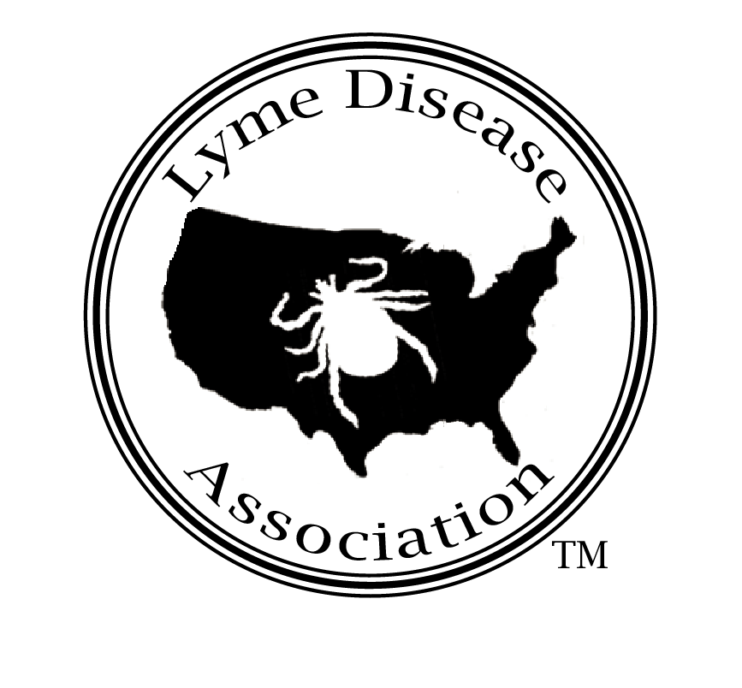
Lyme Disease Association, Inc.
PO Box 1438, Jackson, New Jersey 08527
888-366-6611 Lymeliter@aol.com

TESTIMONY TO RHODE ISLAND ASSEMBLY COMMITTEE
By Pat Smith, President, Lyme Disease Association, Inc. 6-26-03

I am President of the Lyme Disease Association, LDA, and sit on the board of directors of International Lyme and Associated Diseases Society, ILADS, a professional medical society, and am former chair of the [New Jersey’] Governor’s Lyme Disease Advisory Council.

LDA is an all-volunteer national organization providing Lyme disease education and funding for research projects coast to coast, including a past grant to URI for tick control. The LDA has acquired five national affiliates and four chapters and recently along with its CT affiliate, partnered with Columbia University College of Physician & Surgeons to open an endowed chronic Lyme disease research center to be housed at Columbia. The LDA is also poised to announce the creation of a fund to be used for payment to help children suspected of having Lyme obtain a proper diagnosis. Author Amy Tan, Joy Luck Club, Bonesetter’s Daughter, is supporting the fund.

Lyme is the most prevalent vector-borne disease in the U.S. and the most prevalent vector-borne bacterial disease in the world according to the World Health Organization Coordinating Committee. Actions occurring at the federal level relating to Lyme disease are often not well known. For example, The US Army Centers for Health Promotion and Preventive Medicine (CHPPM) has developed a prototype pocket-sized lab to test ticks in the field using sophisticated PCR technology. LDA saw this prototype on our visit there a few years ago. Soldiers may receive immediate treatment in the field if bitten by ticks that test positive for Lyme.

CHPPM has performed risk assessments on military bases in this country since the late 80s/early 90s. Tick populations and infectivity rates from the bases are being stored, now in GPS satellites. While we were there, CHPPM showed us the plan for the development of a prototype helmet to be worn by a soldier in the field with a heads up display. Satellites will beam the tick data to the special helmet worn by a soldier in the field, allowing armies to maneuver around heavy tick concentrations.

NASA and the NIH have a joint culturing project for Lyme disease and other bacteria using microgravity chambers, which mimic conditions in space and in the human body. This work is showing how complicated relationships are from bacteria to bacteria and how they may communicate to evade body defenses and perhaps even treatment.

In 2002, LDA and its CT affiliate worked with Senators and Congressmen to pass a federal bill providing $50 million for Lyme disease research, physician education, and prevention, with one of the goals a definitive diagnostic test. Unfortunately, the session ended before the House took up the bill, but it will be reintroduced this session.

Lyme disease cases nationwide are reported to the Centers for Disease Control & Prevention, CDC. The actual number of Lyme cases meeting the CDC criteria is estimated to be 10 times higher than reported cases. The average number of reported cases nationwide is 18,000, thus about 180,000 actual cases meet the CDC criteria each year.

New York has the highest reported case numbers, although CDC data from 1990-1999 lists Rhode Island with an annual Lyme disease incidence rate of 39 per 100,000 of population, behind only Connecticut. Interestingly, Maine recently reported an upsurge in both tick populations and the disease itself.

Reported cases in the US must meet the Centers for Disease Control & Prevention, CDC, surveillance criteria: a physician diagnosed EM (bullseye) rash, or positive blood work and other system involvement. The CDC warns on its website that doctors should not use its surveillance criteria for diagnosing Lyme. One of the problems inherent in the criteria is the fact that studies have shown that the EM rash appears less than 50% of the time, and another problems lies in the inaccuracies of Lyme disease testing. Despite CDC warnings, many physicians do use the surveillance guidelines to diagnose, instead of making a clinical diagnosis based on symptoms and history as the CDC recommends.

Public Law 107-116 signed by President Bush January 10, 2002 states under CDC “The Committee [Senate appropriations] is distressed in hearing of the widespread misuse of the current Lyme disease surveillance case definition. While the CDC does state that this surveillance case definition was developed for national reporting of Lyme disease: it is not appropriate for clinical diagnosis, the definition is reportedly misused as a standard of care for healthcare reimbursement, product (test) development, medical licensing hearings, and other legal cases. The CDC is encouraged to aggressively pursue and correct the misuse of this definition. This includes issuing an alert to the public and physicians, as well as actively issuing letters to places misusing this definition.”

Excerpts from Lyme disease protocols used by insurance companies seem to support that the insurers improperly use the surveillance criteria to deny treatment to Lyme patients. Antibody response testing such as the ELISA and the Western Blot are not very reliable diagnostic tests for Lyme disease if the CDC 2 step protocol is followed and the 5-band CDC criteria are used. According to a document from the NY Department of Health to the CDC, if they followed the 2-tier testing requirement for 1995 cases (positive ELISA followed by Western Blot), 81% of non-EM cases would not have been confirmed.

recognizes that the current state of laboratory testing for Lyme disease is very poor. The situation has led many people to be misdiagnosed and delayed proper treatment.”

Doctors will try to support their diagnosis of Lyme disease by ordering direct detection tests such as PCR, which doctors feel are more accurate. Insurance companies often do not accept PCR for a Lyme disease diagnosis, although PCR is accepted for other diseases such as HIV, hepatitis, and TB. Insurers also may limit treatment to 28 days and/or substitute orals for IV medications, when doctors often prescribe IV treatment for Lyme disease that has invaded the central nervous system.

Several studies have been done with oral versus IV medications including one published called “Comparison of oral cefixime and intravenous ceftriaxone followed by oral amoxicillin in disseminated Lyme borelliosis” by J. Oksi, et al. Two treatment regimens for disseminated Lyme (mainly neurologic and musculoskeletal manifestations) were compared. A group of 30 patients received orals for 100 days. Another group of 30 patients received intravenous ceftriaxone for 14 days followed by orals for 100 days. The total number of patients with relapses or no response at all and the number of positive polymerase chain reaction findings after therapy were greater in the oral group. The general outcomes of infection in patients with disseminated Lyme after 3-4 months of therapy indicate that prolonged courses of antibiotics may be beneficial.

Dr Brian Fallon, Columbia University, also published that a repeated course of intravenous antibiotic therapy results in marked improvement in memory, attention, and overall functioning. 23 patients with complaints of persistent memory problems who had previously received 4-16 weeks of intravenous antibiotic therapy were given either IV, orals or intramuscular injections. Patients given intravenous antibiotics showed the greatest functional improvement (pain, physical functioning, energy) and the most cognitive improvement even when controlling for differences in cognition at baseline between the groups. The results of this preliminary study were given to the NIH as a basis for applying for and receiving the $4.7 million NIH grant for the treatment study now underway.

We have heard from physicians throughout the country that their insurance carriers strongly suggested they either leave the plan or stop treating Lyme patients long term. A few continue to treat, some refer their patients to long-term treating physicians, while others, fearing reprisals or facing economic hardship, stop seeing Lyme patients. In some states, physicians have been subject to investigations by licensing boards for treating Lyme patients long-term. Sometimes, it has been insurance companies who have filed the complaints against the treating physicians simply for treating long term.

The treatment of Lyme disease is mired in a scientific controversy. The controversy pits academic-based physicians who feel Lyme is cured with 28 days of treatment against physicians in the trenches who are treating Lyme cases and their patients who are experiencing symptom relief from extended treatment. The heart of the argument is that if Lyme is diagnosed and treated early, it can be treated rather successfully with a four to six week course of antibiotics; however, because of a lack of a definitive test, its ability to mimic other diseases, and the presence of co infections with other tick-borne diseases, diagnosis and treatment are often delayed which may cause chronic disease. Research has also shown that the Lyme disease spirochete, similar to the one that causes syphilis, can enter the central nervous system less than a week after a tick bite. Neuroborreliosis, Lyme disease in the central nervous system, can be very difficult to eradicate.

OSHA, Occupational Health & Safety Administration, recognizes the seriousness of Lyme disease. Their Hazardous Information Bulletin discusses the dangers of Lyme disease and the importance of early diagnosis and treatment and states “Lyme disease in a later stage is more difficult to diagnose, and treatment may become prolonged and costly.”

New Red Cross blood donor guidelines distinguish between Lyme disease and chronic Lyme disease, “Accept persons with Lyme disease if they were treated, the disease resolved and at least one year has passed. Those with chronic Lyme disease are not eligible to donate blood.” The American Society of Clinical Pathologists (ASCP) blood donor guidelines state under “serious illness,” “defer indefinitely… Lyme disease.”

Clinical physicians and researchers provide many theories based on published research to explain how the spirochete can persist in the body after treatment. Research performed by Dr. David Dorward, NIH, has shown that the spirochete that causes Lyme disease can enter a cell and come out the other side cloaked in the cell’s membrane, thus eluding the body’s immune system, which no longer recognizes the spirochete as a foreign invader. The spirochete has also been shown to persist within macrophages by Montgomery et al. and in Nanagara, Duray and Schumacher, spirochetal antigens have been found to persist in the joint in chronic Lyme disease, both intracellularly and extracellularly in deep connective tissue, suggesting the ability to elude host response and antibiotic treatment. Also, research by Brorson & Brorson shows that the spirochete, in vitro, is able to change itself into different forms. The change in form may occur in vivo under conditions unfavorable to the spirochete. The work of Alban et al indicates that the spirochete reacts to conditions of serum starvation by changing cell morphology. This can explain how the spirochete is able to survive periods of nutrient deprivation in host tissues. Some of these new forms may lack a cell wall, thus eluding cell-wall targeting antibiotics. When the climate gets better, the cell wall-less forms may change back into the spirochete, and the disease may become active again.

Dr. Reinhard Straubinger, a world renown Lyme researcher with famous dog studies at Cornell, wrote to the NY State Department of Health that he was able to culture spirochetes from 3/23 30-day antibiotically-treated dogs (human dosage comparable), detect spirochetal DNA in 20, and quantify spirochetal DNA in 12. “In contrast to many human studies we could show persistent infection, because a lengthy time period separated the phase of treatment and the phase of testing. …the spirochetes may need sufficient time after antibiotic treatment in order to recover and multiply to sufficient numbers so we can detect them with the techniques we have currently available.

The jury is still out. Controversy over Lyme swirls while patients continue to be denied treatment. Last year, Rhode Island took the lead and passed a most important piece of legislation to protect physicians who treat. That was the first step in helping patients receive the medication they need to help them live rather than exist.

Risky behavior for acquiring Lyme disease can be walking your dog, jogging through the park, your child playing in a sandbox. Everyone has the potential to become a Lyme victim, and without appropriate treatment, chances are increased that early Lyme can turn to chronic Lyme. Without continued treatment to resolve symptoms, the heart, eyes and brain, can become infected producing heart block, blindness, and memory loss and seizures. Chronic Lyme disease patients are not going away. Their numbers are increasing and will continue to increase without appropriate treatment regimens.

Chronic Lyme patients do require extended treatment but are often able to remain productive members of society, working and being educated. Rhode Island has the opportunity to take the lead in this issue by introducing and passing the strongest protection anywhere for patients’ rights to be treated and reimbursed for Lyme disease treatment. Remember, you could be the next victim.

Lyme & Other Tick-borne Diseases: A 21st Century View, LDA Princeton medical conference brochure, November 10, 2001
Roberts, David M., et.al., “The bdr Gene Families of the Lyme Disease and Relapsing Fever Spirochetes,” Emerging infectious Diseases, 6(2), 2000. Centers for Disease Control
CDC LD Chart: LD Cases reported by State Health Departments 1990-1999 www.cdc.gov/ncidod/dvbid/lyme/ldcases90-99.htm
Bangor Daily News 3/30/02 as reported by Maine’s Bureau of Health
Dept of Labor, Health, and Human Services, and education, and related Agencies Appropriations Act 2002
Aetna guidelines http://www.aetnaushc.com/cpb/data/CPBA0215.html, Oxford Health, Medical Policy Manual
NYSDOH to CDC April 15, 1996
Eur J Clin Microbiol Infect Dis. 1998 Oct;17(10):715-9.
Fall 1999 issue of the Journal of Spirochetal and Tick Borne Diseases
OSHA Hazardous Information Bulletin April 20, 2000
Press release American Society of Clinical Pathologists
Journal of Immunology 1993 Feb1;150(3):909-15
Human Pathology, 1996 Oct;27(10)1025-34
Infection 1997Jul-Aug;25(4):240-6
Microbiology 2000Jan;146 (Pt 1):119-27
Dr. Straubinger’s letter to NYSDOH, November 22, 2001

