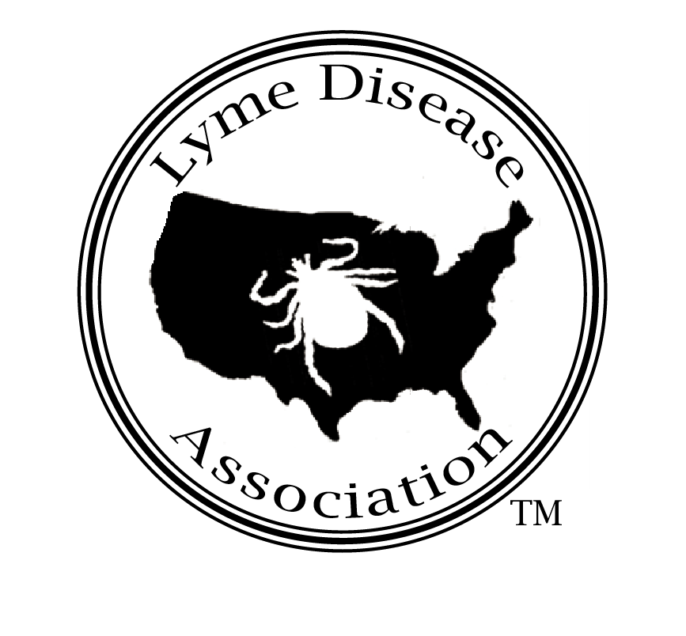
Lyme Disease Association, Inc.
PO Box 1438, Jackson, New Jersey 08527
888-366-6611 Lymeliter@aol.com 732-938-7215 (Fax)
LymeDiseaseAssociation.org

Julie L. Gerberding, MD
Director
US Centers for Disease Control and Prevention
600 Clifton Road
Atlanta, GA 30333
jyg2@cdc.gov

June 19, 2007

Dear Dr. Gerberding,

I am writing on behalf of the Lyme Disease Association (LDA) and the undersigned groups in reference to the Council of State & Territorial Epidemiologists (CSTE) revisions to the National Surveillance Case Definition for Lyme disease proposed by Matthew Carter. Based on the following analysis, we are opposed to CSTE adopting this amendment and are opposed to any potential CDC acceptance of this revision should it be adopted by CSTE.

There are key problems with the 2007 proposed revisions to the National Surveillance Case Definition for Lyme disease. These problems could undermine the CDC’s goals of defining the geographic distribution, monitoring disease trends, identifying risk factors for transmission in areas where Lyme disease is newly emerging, and measuring the public health surveillance burden over time.

The proposal raises concerns that the increasing number of Lyme disease cases places a burden on local health departments. Lyme disease has only become a burden because of the increasing numbers of cases. The CDC, with the help of more than 3,000 counties and territories,(1) reports that the number of reported Lyme disease cases nearly doubled since 1991 to more than 23,000 reported cases in 2005.(2) The 2005 actual number of reported cases per county varied from 0 cases in 5 states (Arkansas, Colorado, Mississippi, Nebraska, and Oregon) to 5,565 cases in New York.(2) Thirty-seven of the fifty states had fewer than 100 reported cases of Lyme disease in 2005.(2) The burden on local health departments appears to be high only for the states with the highest Lyme disease burden. In any case, even the amendment author states that “the revised surveillance case definition alone will not decrease the Lyme disease surveillance burden.”(4)

The proposed revisions to the surveillance case definition for diagnostic utilization of an erythema migrans (EM) rash will worsen existing problems with underreporting Lyme disease. Under the proposed case definition, an EM will not be confirmatory unless there is a known exposure to Lyme disease. Currently, “known exposure” is defined as exposure in a county in which at least two confirmed cases have been previously acquired or in which established populations of a known tick vector are infected with B. burgdorferi.(3) The problem is that many counties may never have enough cases of Lyme disease to be considered as an area of known exposure or may not have the expertise to identify established populations of a known tick vector infected with B. burgdorferi. If the EM is not now classified as pathognomonic for Lyme disease, a county may feel a false sense of security and never assess tick populations for infection rates. Emerging areas of Lyme disease will go unrecognized.

The proposed revisions to require laboratory confirmation of a case of an erythema migrans rash in areas where there is no known exposure could also further worsen the underreporting of Lyme disease. The definitions of a qualified laboratory assay is a “(1) a positive culture for Borrelia burgdorferi, (2) two-tier testing interpreted using established criteria [1], or (3) single-tier IgG immunoblot seropositivity interpreted using established criteria.”(4) Most Lyme disease patients presenting with an EM rash are now treated without the need for a culture or laboratory tests. Even if laboratory tests are available, antibodies take weeks to reach detectable levels,(5) and early antibiotic treatment can abrogate immune response. (6) To reiterate, the requirement for laboratory confirmation may cause emerging areas of Lyme disease to go unrecognized and may cause people with early disease to progress to disseminated infection.

While the proposed revisions have incorporated the much-needed probable and suspected case definitions, the proposed definitions need to be further expanded to ensure they do not contribute to the underreporting problem. For the first time, important clinical presentations including neurologic(7) and psychiatric manifestations(8) can be included in the probable cases of Lyme disease. Unfortunately, the number of cases of Lyme disease meeting the probable case definition will be underreported when requiring laboratory evidence for this category. The numbers of Lyme disease patients who will fail to be confirmed by the two-tier testing or single-tier IgG immunoblot testing will remain unknown under the proposed definition of probable cases.

The proposed amendment limits the reporting to CDC to confirmed and probable cases only, further complicating the underreporting problems. Often, the positive laboratory report is the only information available on Lyme disease cases. In Connecticut, for example, only 25% of physicians who had made a diagnosis of Lyme disease reported a case.(9) The CDC could report the numbers of cases of positive laboratory tests for Lyme disease as a sentinel indicator for cases of Lyme disease in emerging areas.

The proposal to include “a single-tier IgG immunoblot seropositivity interpreted using established criteria” test is a welcome start to expanding the laboratory testing criteria.(4) Unfortunately, the sensitivity of the IgG immunoblot is worse than first described in proficiency testing.(10) A proposal to require any laboratory confirmation is weakened when examining the reliability of laboratory testing for Lyme disease.

In conclusion, the proposed revision on the one hand improves the current system by permitting the reporting of confirmed and probable cases; on the other hand, it dilutes confirmed cases by restricting the use of EM in diagnosis, which will lead to many current confirmed cases reclassed as probable and lead to many cases in the south and west never being reportable. An opportunity exists to encourage states to improve surveillance; however, the amendment does not go far enough in encouraging states to track cases not meeting the already narrow CDC surveillance case definition. The new restrictions on the definition of erythema migrans will increase underreporting. Underreporting will affect the perception of risk both by the public and by government. It may lead to increased incidence through failure of states to allocate resources towards a problem they think is minor and through failure of the federal government to fund a disease whose numbers appear limited. Therefore, this proposal may worsen the surveillance for Lyme disease rather than giving “public health officials a more complete measure of the surveillance burden that can be used to guide the allocation of scarce public health resources.” A proposal of such significance to public health will be more beneficial when implemented after more thorough research and additional discussion.

∞
End Notes

International Lyme & Associated Diseases Society, Inc.
Ray Stricker, President
PO Box 341461
Bethesda, MD 20827
301 263 1080

Cape Cod Chapter, LDA
Nancy Wood
Karen Hallett-LaRoche, Co-Chairs
216 Church Street
West Barnstable, MA 02668

Harford County Lyme Disease Support Group, Inc.
Jean F. Galbreath, President
P. O. Box 13
Street, Maryland 21154

Texas Lyme Disease Association
Donna Reagan
PO Box 1811
Colleyville, TX 76034-1811

Time For Lyme, Inc
Diane Blanchard
Debbie Siciliano
Co-Presidents.
PO Box 31269
Greenwich, CT 06831

RI Chapter, LDA
Co-Presidents
Julie Merolla
Lisa Larisa
2348 Post Road
Warwick, RI 02886
401-439-5873

Newtown Lyme Disease Task Force
Maggie Shaw, RN
82 Eden Hill Road
Newtown, CT 06470
203-270-3301
Fax 203 270 3301

STAND UP FOR LYME
J. David Kocurek, Ph.D., President
7007 Orchard Hill Ct., Suite 205
Colleyville, TX 76034-6623

Lyme Disease Association of Southeastern Pennsylvania, Inc.
Douglas W. Fearn, President
PO Box 944
Chadds Ford, PA 19317

Greater Danbury Lyme Disease Support Group
Dr. Pat Bartlett ND
21-42 Hudson Street
Bethel, CT. 06801

Lyme Association of Greater Kansas City, Inc.
P.O. Box 25853
Overland Park, KS 66225
Contact person: Ila Utley, President
ilaU @everestkc.net

Vermont Lyme Network
Dayle Ann Stratton, Director
31 Carver Street
Brandon, Vermont 05733
www.vermontlyme.org

MILITARY LYME SUPPORT
MONTANA LYME SUPPORT
ALASKA LYME SUPPORT
Representative:
Colleen Nicholson
7 Perry Avenue
Bayville NY 11709
(516)558-7340

Lyme Disease Network of NJ, Inc.
Carol & Bill Stolow
E. Brunswick, NJ
www.Lymenet.org

California Lyme Disease Association,Inc
Phyllis Mervine
Ukiah CA
Pmerv@hughes.net

Delaware Lyme Support
Sue Driver, Founder
4926 Old Capitol Trail,
Wilmington, DE 19808

Maine Lyme Disease Support Groups
Constance Dickey RN
11 Constitution Ave.
Hampden, Me 04444

Florida Lyme Advocacy, Inc.
Lori Hoerl
31 N. 3rd St.
lorbell1@aol.com
Fernandino Beach, FL 32034

Brookfield-Wolfeboro
New Hampshire Lyme Support
Pam Dugas
101 Garney Rd.
Brookfield, NH 03872
Ph:603-522-8742

Minot Lyme Disease Support Group
Lloyd Ann Caston
1810 66th St NW
Minot, ND 58703
homes4u@LloydAnn.com

Oregon Lyme Disease Network
Theresa Denham
Bend, OR
jmr@empnet.com

Gear Up for Lyme
Stephanie J. Woolwich-Holzman VMD
www.gearupforlyme.com
85 Hill Lane
Arlington, VT 05250

New York City Lyme Disease Support Group
Ellen Lubarsky
315 West 86th Street
NY, NY 10024

WI. Lyme Disease Groups
President - Mike Nickel
6705 County Road J
Weston, WI. 54476
715-574-6633

Lyme Disease Network of Middle Tennessee
Kathy Townsend
email: lyme@tnlyme.org
11 Music Square East
Nashville, TN

Marilyn Steinbach
Mindy Abel
Georgia Lyme Association
Cumming, GA 3004
GeorgiaLyme@yahoogroups.com

Lyme Disease Education and Support Groups of Maryland
After the Bite
Lucy Barnes
631 Railroad Ave.
Centreville, MD 21617

Southern Delaware Lyme Support Group
Deborah Houston
Phone #: 302-541-4623
justme_dj54@hotmail.com

Leslie Giardiello
Pennsylvania Chapter, LDA
61 Downing Dr.
Wyomissing, PA 19610

Hudson Valley Lyme Disease Assn.
143 Bart Drive
Poughkeepsie, NY 12603
Auerjill@aol.com

Cc:
The Honorable Christopher Dodd (CT)
US Senate

The Honorable Charles Schumer
US Senate (NY)

The Honorable Frank Pallone (NJ)
Chair, US House Health Sub Committee

The Honorable Christopher H. Smith (NJ) Co-Chair Lyme Disease Caucus,
US House of Representatives

The Honorable Tim Holden (PA)
Co-Chair Lyme Disease Caucus,
US House of Representatives

The Honorable Bart Stupak (MI)
Co-Chair Lyme Disease Caucus,
US House of Representatives

Arizona Lyme Disease Association.
ArizonaLyme@yahoogroups.com
www.azlyme.org (under construction)
Karen Genest
2314 E Tahitian Way
Gilbert, AZ 85234
480-632-6444

Greenville Lyme Advocacy & Support Group
Kathleen Liporace
106 East Hypericum Lane
Greenville, SC 29615

Wolcott Lyme Disease Network
Tim and Colleen Collins
179 Brooks Hill Rd
Wolcott, Ct 06716

Orange County, California CALDA Support
Tina Van Divier
32181 Sea Island Dr
Dana Point, CA 92629

Eva Haughie
President, Empire State Lyme Disease Association, Inc.
PO Box 874
Manorville, NY 11949

