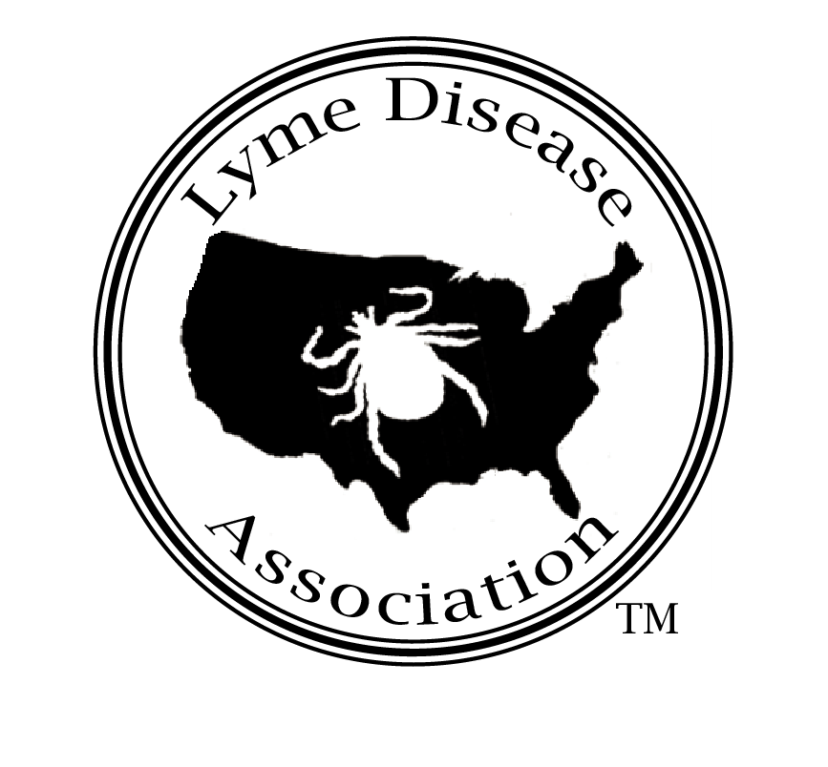

LD 1521 Testimony from: Lyme Disease Association, Inc. (LDA)
Patricia Smith, President Jackson, New Jersey
Maine Charity registration # CO3875
National patient non profit dedicated to funding Lyme disease prevention, education, research, and patient support
www.LymeDiseaseAssociation.org Lymeliter@aol.com 888 366 6611

To Co-Chairs, Senator Nancy Sullivan and Representative John Brautigam, and Members of the Insurance and Finance Committee and Senator Bruce Bryant, Sponsor:

I am submitting testimony today regarding Maine Bill LD 1521. While the Lyme Disease Association (LDA), a national non-profit that works with Lyme groups nationwide, is pleased that mandatory insurance coverage for and awareness of Lyme disease has been introduced in the State of Maine, the LDA’s position mirrors that of many Maine support groups− amendments must be added before considering bill passage in order to support patient interests.

A history in Maine shows that patients have difficulty obtaining diagnosis and treatment for Lyme disease, a serious disease which can become chronic and attack joints, muscles, heart and the brain. The bacterium can enter the brain less than 24 hours after a tick bite. Once it becomes chronic, it is difficult to control or eradicate with short-term antibiotic treatment. Patients sometimes require repeated courses of antibiotic therapy over months or years to eradicate or control symptoms.

Patients and treating physicians struggle with regulations and policies from government agencies, insurance companies, and others in order for patients to receive the treatment necessary to live productive lives. Doctors who treat the disease are already scarce due to the controversy, and patients often travel many hours to other states to obtain appropriate treatment.
The concern here is that the language of Sec. 1. 24-A MRSA §2745-H, Lyme disease coverage, is too general in nature and could easily be manipulated by insurers to the detriment of Lyme disease patients. For example, this proviso has no definition for Lyme disease contained within the language. If the insurer interprets that language to mean Lyme disease as defined by the federal Centers for Disease Control & Prevention (CDC), many Lyme patients will remain undiagnosed and untreated. The CDC indicates that its definition is for surveillance purposes only and not meant for diagnosis nor for reimbursement. That fact has not previously stopped insurers, however, from using the definition.
If insurers interpret the language using the 2006 Infectious Diseases Society of America (IDSA) guidelines for Lyme disease treatment as a basis for definition, patients will be denied treatment, and maybe even the diagnosis of Lyme disease will be disputed. These guidelines do not recommend any doctor discretion in diagnosing, any long-term treatment, and do not recognize chronic Lyme disease as a treatable condition. This is at odds with the fact that Columbia University is poised to open the first endowed Center to study chronic Lyme disease in the world on April 30, 2007, with monies raised by the patient organizations, LDA and its Connecticut affiliate, Time for Lyme
These IDSA guidelines have already begun to be cited by insurers, government agencies, even pharmacists, to prevent Lyme disease patients from receiving treatment necessary for their disease. These same guidelines are currently under investigation by the Connecticut State Attorney General, who has served the IDSA itself with a Civil Investigative Demand (subpoena), citing possible exclusionary conduct and monopolistic practices in the guidelines’ development process as a basis for his action.

We feel that the use of these guidelines as a definition for Lyme would almost certainly result in the increase in chronic Lyme disease cases due to lack of doctor discretion in diagnosing. Chronic Lyme is more costly to patients physically, mentally, and financially. According to a 1998 study in a CDC journal, early Lyme costs* averaged $161 per patient and neurologic longstanding Lyme disease averaged $61,243. Chronic Lyme is also more costly to the state and federal government in terms of disability and other costs such as those incurred by school districts for impacted areas such as special services, home instruction, and substitute teachers.
The LDA and its Rhode Island Chapter worked with the legislature there to develop and pass a bill into law in Rhode Island which provides mandatory insurance coverage for Lyme patients. Additionally, the legislature passed into law protection for treating physicians. These laws have more specific defined language which may be useful to the Maine legislature in crafting an amendment which will benefit Maine patients, since Rhode Island patients are currently receiving benefits under the existing law
Maine needs an education program. In 2005, it was 10th nationally in rate of incidence (18.7/100,000 pop.). The federal CDC states that only 10% of cases that meet its narrow surveillance criteria are reported, therefore Maine’s 247 reported cases in 2005 represent about 2,470 actual cases that meet the CDC surveillance criteria. That number does NOT in any way count the number of people contracting Lyme who do not meet the CDC criteria, which are for surveillance, not diagnostic, purposes.

In reference to Section 3 of the bill, the language therein should be amended to include the participation of members of the public in the process, specifically, Lyme patient advocates, who are stakeholders in the process. Government agencies often do not have the resources or manpower to be on top of every issue in their state, and patient input is key to having a balanced report which reflects reality rather than just fiscal concerns which state agencies often face.

This well-intentioned bill should have further committee discussion with stakeholders to develop amendments to ensure it will be beneficial for Maine residents. Thank you.

Steere, Allen, Mandel, Douglas, and Bennett’s Principals & Practices of Infectious Diseases, 4th ed. 1995.
Martin I. Meltzer The Cost Effectiveness of Vaccinating against Lyme Disease CDC Emerging Infectious Diseases; Vol.5, No.3; 1999 May-June;5(3)321-8. * This is in 1996 costs not adjusted to 2007. The following additional significant costs to society aren’t measured by this table: special education needs for children, disability, increased medical and insurance costs, and livestock losses, etc. Also, there are personal loses: friends, employment, self, esteem, domicile, and breakup of families.
Patricia Smith, Wall Township, NJ, Board of Education member NJ School District Study on Impact of Lyme Disease on School Districts presented in Washington DC Congressionally hosted meeting with CDC & NIH, March 12, 1992.

