Testimony of Patricia V. Smith
President, Lyme Disease Association, Inc.
March 13, 2007

Health and Government Operations Committee
Peter A. Hammen, Chair
Marilyn R. Goldwater, V. Chair

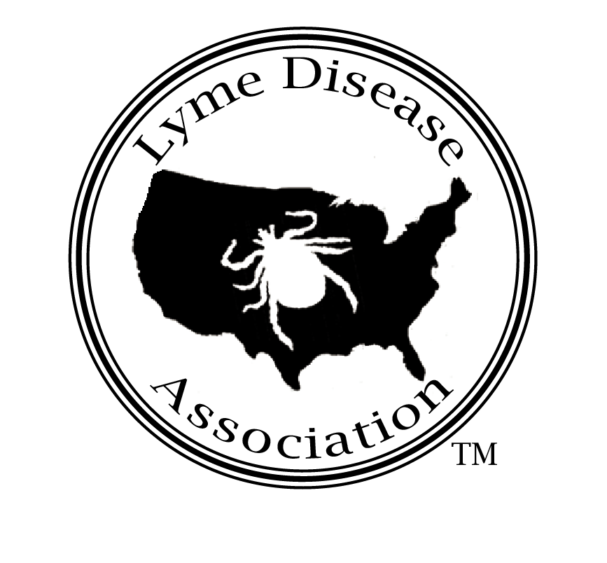

Lyme Disease Association, Inc.
MD Charity # 13447
www.LymeDiseaseAssociation,org
888-366-6611
mailto:Lymeliter@aol.com

Mr. Chairman,

I am submitting testimony today in regard to HB 836 (Montgomery). While the Lyme Disease Association (LDA), a national non-profit with affiliated groups in Maryland, is pleased that an awareness bill has been introduced, the LDA feels that amendments must be added to the bill to support patient and treating physician interests.

A history in Maryland shows that patients have difficulty obtaining diagnosis and treatment for Lyme disease, a serious disease which can become chronic and attack joints, muscles, heart and the brain. Once it becomes chronic, it is difficult to control or eradicate with short-term antibiotic treatment. Patients sometimes require repeated courses of antibiotic therapy over months or years to eradicate or control symptoms.

Patients and treating physicians struggle with regulations and policies from government agencies, insurance companies, and others in order to receive the treatment necessary for the patients to live productive lives. Doctors who treat the disease are already scarce due to the controversy,and patients often travel many hours to other states to obtain appropriate treatment.

The concern here is that the Maryland Department of Health and Mental Hygiene (DHMH) will follow the path it has already begun and disseminate biased information from physician organizations such as the Infectious Diseases Society of America (IDSA). These IDSA treatment guidelines recommend against physician discretion in diagnosing Lyme disease as well as against most classes of antibiotics used by treating physicians and alternative treatments and supplements--bottom line, no treatment for chronic Lyme patients.

This supposition about the DHMH is based upon its already failed attempt to work with patient groups here in Maryland. A committee was formed and patients met with DHMH, but the direction of DHMH was biased toward short-term therapy, despite patient examples of positive responses to longer-term therapy. Patient representatives withdrew from the committee.

Maryland needs an education program. In 2005, it was 7th nationally in total case numbers (1235) and 9th in rate of incidence (22.1/100,000 pop.). The Centers for Disease Control & Prevention (CDC) states that only 10% of cases that meet its narrow surveillance criteria are reported, therefore about 12,350 new cases of Lyme disease occurred in Maryland in 2005. That number does NOT in any way count the number of people contracting Lyme who do not meet the CDC criteria, which are for surveillance, not diagnostic, purposes. CDC statistics indicate Lyme is most common in boys ages 5-19 and combined boys & girls, ages 5-9.

Maryland needs an educational program that will be beneficial to patients. At this time, I ask that you only consider favorably the passage and release of HB 836 with the following amendments to protect the physicians who treat and the patients who require treatment−amendments supported by many Maryland Lyme disease patient organizations:

REPLACE existing Section A (2) line 15-17, (IV) with
(IV) Develop and disseminate balanced educational materials to health care providers including National Guideline Clearinghouse peer-reviewed guidelines for the diagnosis and treatment of early and chronic Lyme disease;

ADD in Section 2, as lines 27-28
AND BE IT FURTHER ENACTED, That this act shall take effect October 1, 2007. It shall remain effective for a period of two years and the provisions herein shall be accomplished by October 1, 2009, and with no further action required by the General Assembly, this Act shall be abrogated and of no further force and effect.

Thank you for your consideration. Do not hesitate to contact me. Pat Smith, President, LDA

