Madam Chairwoman (Senator Conway) and Committee Members,

Thank you for this opportunity to testify today.

All that glitters is not gold, and if Shakespeare were here today, he would agree that adage applies to the well-intentioned HB 836. The appealing title, Public Health- Lyme Disease - Public Awareness, belies the danger lurking in the language—a danger which threatens all Maryland residents—those with and without Lyme disease and the doctors treating Lyme disease.

The problem with the bill lies in its language which mandates distribution of materials to health care providers about Lyme disease “including the latest consensus guidelines for diagnosis and treatment of Lyme disease. (A2 (IV) lines 22, 23)

That language alludes to the Infectious Diseases Society of America (IDSA) guidelines which do not recommend doctor discretion in the diagnosis of Lyme disease, do not recommend long-term treatment, do not recommend whole classes of antibiotics for treatment, and even do not recommend alternative treatment & supplements for Lyme disease.

These guidelines will:
- result in patients being denied treatment for Lyme disease
- result in patients being denied alternative treatment for Lyme disease
- limit doctor discretion in diagnosing Lyme disease
- result in more chronic Lyme disease and
- result in more costs to the State in disability & education due to the resultant increase in Chronic Lyme Disease.

Yet the bill mandates that the Maryland Dept. of Health & Mental Hygiene (DHMH) shall distribute these very same restrictive IDSA guidelines--guidelines which you probably are unaware--are currently under investigation by the Attorney General of Connecticut, who has served the IDSA itself with a Civil Investigative Demand (subpoena), citing possible exclusionary conduct and monopolistic practices in the guidelines’ development process as a basis for his action. And the bill includes $1,334,100 of State money to distribute guidelines which may be in violation of antitrust law.

No governmental body wants to find itself in the shameful and embarrassing position of creating a law which not only harms its populace but which mandate guidelines to be distributed that may be in violation of the anti trust laws of the United States. I am here today to provide this necessary background for you to make a decision that will be beneficial to this legislature and to Maryland residents.

The national LDA and the Maryland Lyme disease groups are opposed to HB 836. The consequences to all could be devastating, especially to age group 5-9, our children, who run the highest risk of acquiring Lyme disease. Doctors would not be able to diagnose using their clinical discretion and many children would get missed, resulting in the tragedy of chronic disease and costing the child his/her entire childhood.

My daughter was 11 when she was diagnosed, and she missed most of her middle and high school. A doctor here in Maryland helped her to break a three-year cycle of temporal lobe seizures due to Lyme. With years of long-term and alternative treatment, not possible under these guidelines, she was able to graduate Phi Beta Kappa and with honors from Johns Hopkins University. That doctor today no longer treats Lyme patients due to the controversy surrounding the disease. How many more will no longer treat if this bill becomes law? Vote for patients by voting against this bill today.
Testimony of Patricia V. Smith HB 836
President, Lyme Disease Association, Inc.
April 4, 2007

Education, Health and Environmental Affairs Committee
Senator Joan Carter Conway, Chair
Roy P. Dyson, V. Chair
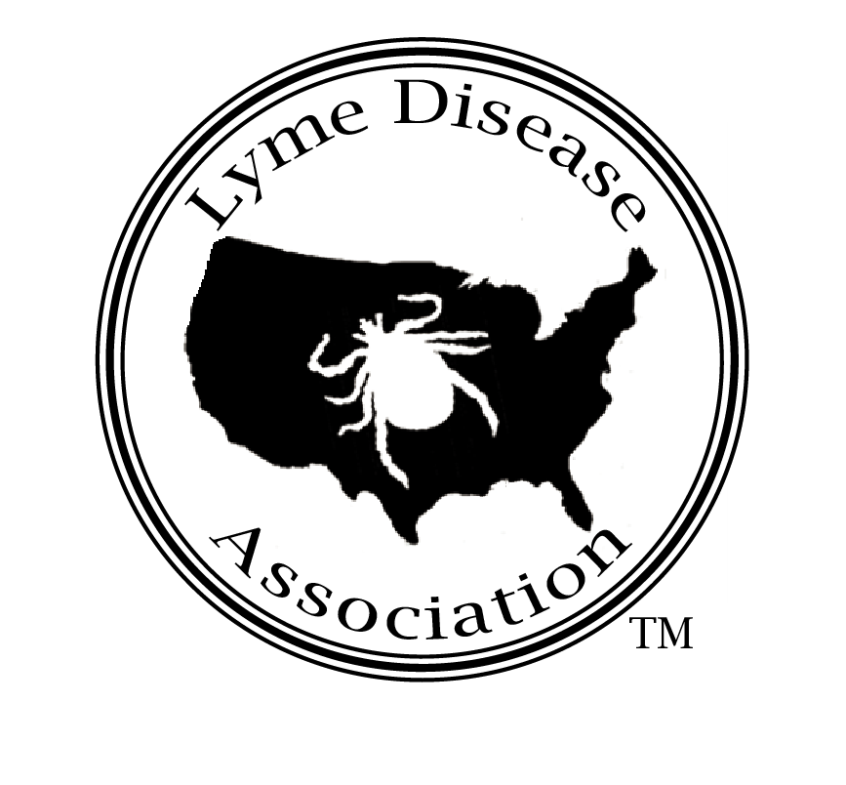

Lyme Disease Association, Inc.
MD Charity # 13447
www.LymeDiseaseAssociation,org
888-366-6611
Lymeliter@aol.com

National all-volunteer non profit patient group dedicated to funding
Lyme disease education, prevention, research and patient support

Endnotes

Wormser, G, et al, “The Clinical Assessment, Treatment, and Prevention of Lyme Disease, Human Granulocytic Anaplasmosis, and Babesiosis: Clinical Practice Guidelines by the Infectious Diseases Society of America;” Clinical Infectious Diseases 2006;43:1089-134
Lyme Disease Association, Inc.; compilation of patient complaints on use of current IDSA guidelines and the prior version which were less restrictive, to cut of patient treatment, diagnosis, and dispensing of prescriptions
Coyle, Marcia, “Antitrust Scrutiny of Lyme guidelines,” National Law Journal, January 22, 2007
CDC website

